PROGRAMME DRAFT

PHILOSOPHY OF MENTAL HEALTH: FROM STRATEGY TO IMPLEMENTATION
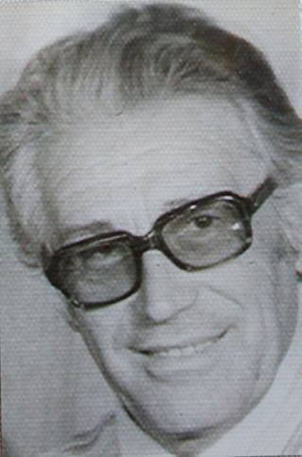

Opening Ceremony: WPA Secretary General Introduction
100 Anniversary from the birth of Prof. Dr Stoyan T. Stoyanov
PANEL I: Philosophy-into-practice
Presentation of the Springer Nature co-edited book “International Perspectives in Values Based Mental Health Practice”, WPA Section for Philosophy and Humanities
PANEL II: Round Table “Psychiatry in Crisis”
National Strategy for Mental Health
PANEL III: Advances in Psychosis Research
Oral Presentations
PANEL IV: Challenges in Translational Psychiatry
Oral Presentations

Co-Sponsors:
National Center for Public Health and Analyses
Research Institute at the Medical University of Plovdiv
University Center for Philosophy and Mental Health
Multidisciplinary Digital Publishing Institute, Basel, Switzerland
(International Journal of Environmental Research and Public Health; Diagnostics)
Oxford University Collaborating Center for VBP

Organizer declares no conflict of interests.

